Adding variable to electronic site

Initially we have some attributes in registration page of TrainingStorefront site, you want to add some extra attribtes we need to fallow following steps,

Step1:
register.tag:-

<formElement:formInputBox idKey="register.mobileNumber"
labelKey="register.mobileNumber" path="mobileNumber" inputCSS="form-control" mandatory="true" />

Step2:

create item for customer, add attribute as mobileNumber,

<typegroup name="Customer">
<itemtype code="Customer" autocreate="false" generate="false">
<attributes>
<attribute autocreate="true" qualifier="mobileNumber" type="java.lang.String">
<modifiers read="true" write="true" search="true" optional="true"/>
<persistence type="property" />

</attribute>
</attributes>
</itemtype>
</typegroup>

Step3:
ant clean all

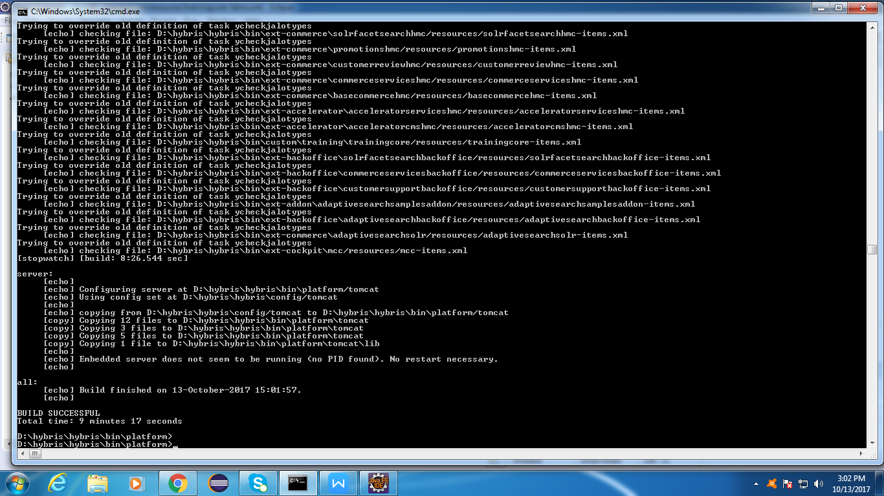

Step4:

In RegisterData, RegisterForm that new attribute is added i.e mobileNumber

Step5:

=> Set mobileNumber to RegistrationData and get that mobileNumber from ‘Form’.

data.setMobileNumber(form.getMobileNumber());

=>In LoginPageController.java

=>set mobileNumber in processRegisterUserRequest() method.

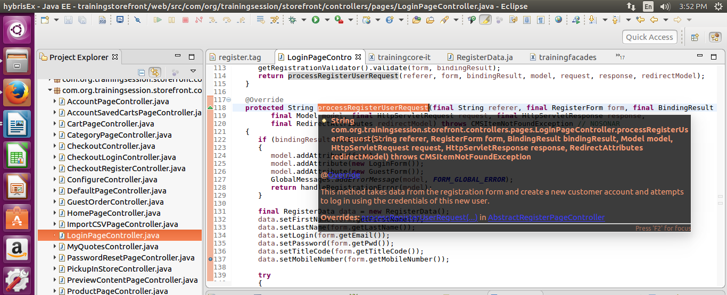

Step 6:
Now we can provide configuration for our customized attribute(mobileNumber).
trainingfacade-beans.xml:-
<bean class="de.hybris.platform.commercefacades.user.data.RegisterData">
<property name="mobileNumber" type="String"/>
</bean>

Step 7:
Create facade
TrainingDefaultCustomerFacadeImpl that customized class need to extends DafaultCustomerFacade

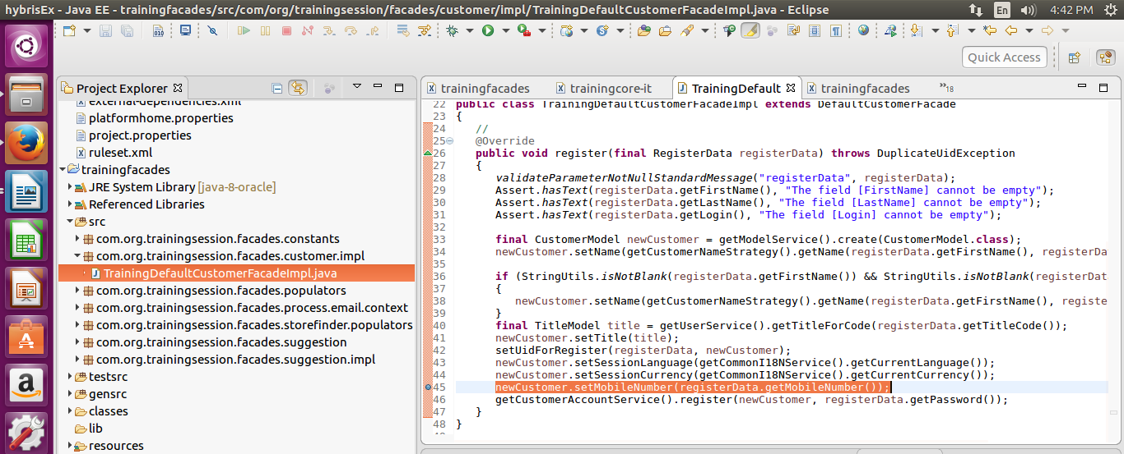

=>Set mobileNumber attribute to CustomerModel and get that mobileNumber Attribute from RegisterData.

newCustomer.setMobileNumber(registerData.getMobileNumber());

Step 8:
=> Provide Configuration for TrainingDefaultCustomerFacadeImpl class in TrainingFacade-spring.xml
<bean id="trainingDefaultCustomerFacade"
class="com.training.facades.customer.impl.DefaultTrainingCustomerFacadeImpl"
parent="defaultCustomerFacade" >
</bean>

Step 9:
Run server . ./hybrisserver.sh debug

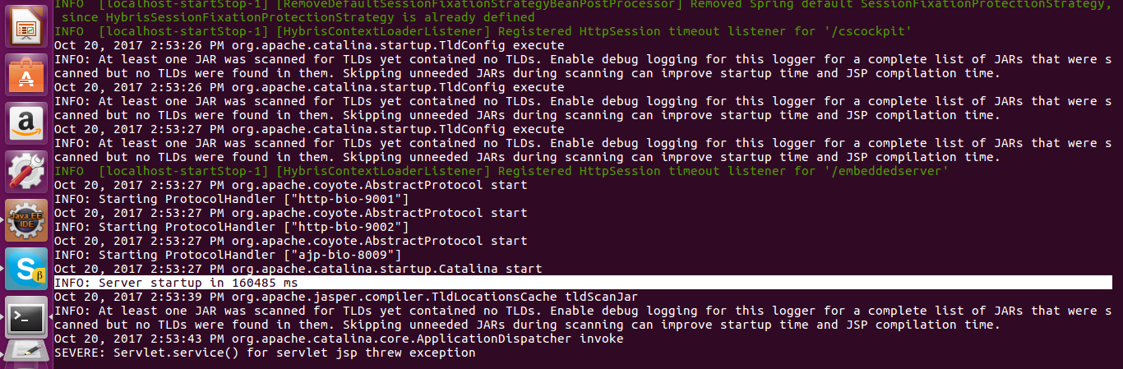

Step 10:
Access the site using URL as
https://training.local:9002/trainingstorefront/

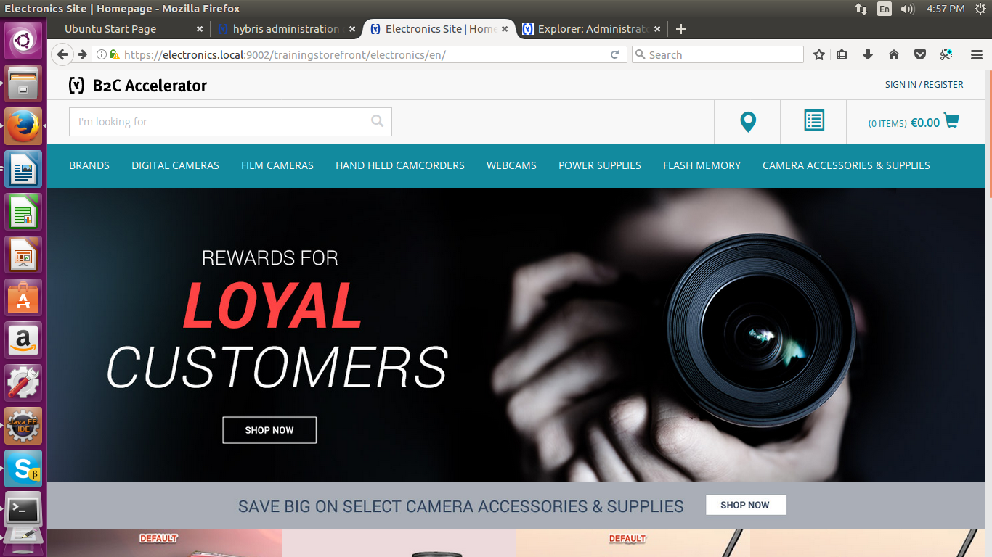

Step 11:
now go for registration Link and fill registration form.

Step 12:
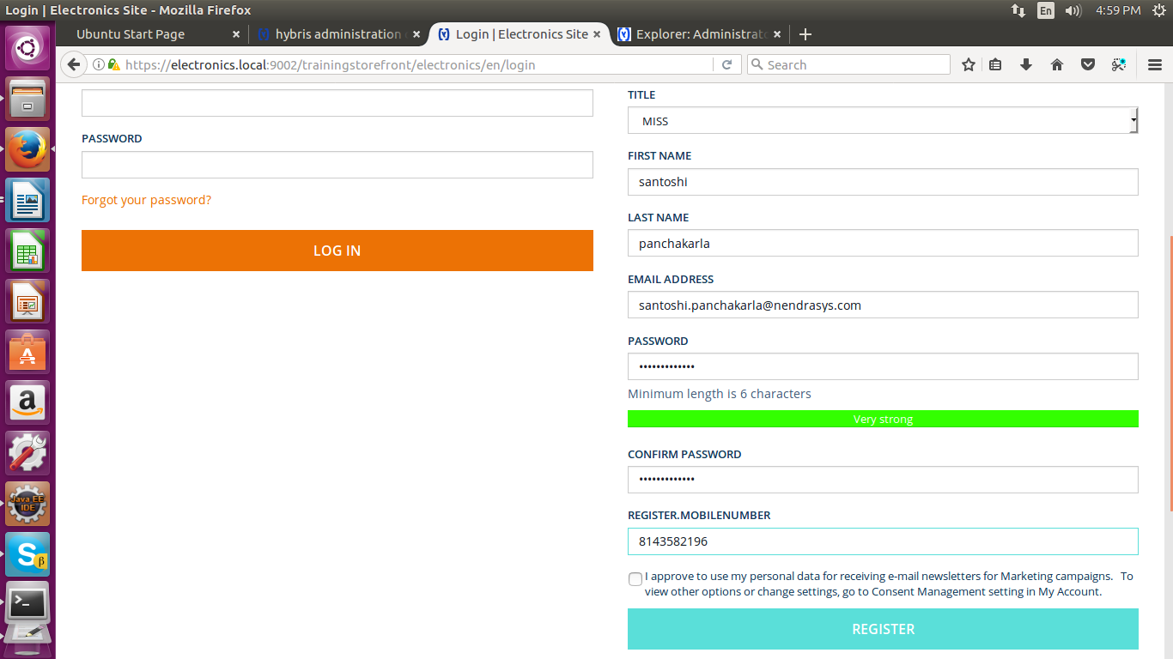

=> successfully completed registration and now we can access that site using your credentials.
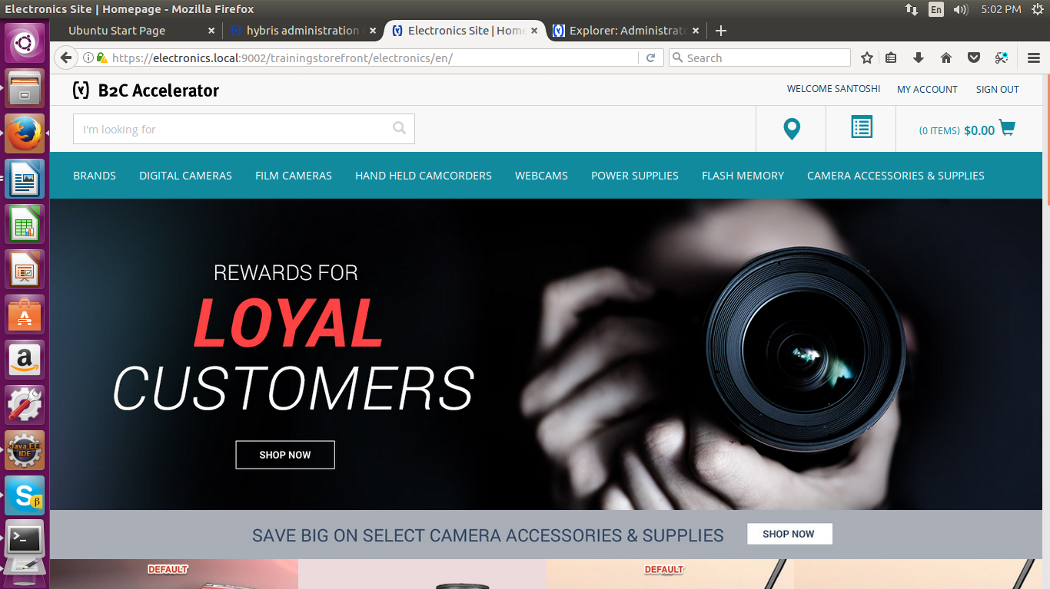
Step 13:
=> check in Hmc, wheather you inserted attribute is added in DB or not.
To access HMC hit URL as
https://localhost:9002/hmc/hybris/
Open HMC--> through credentials-->login--> user->customer-->search->select mail
-->administration-->check for mobileNumber attribute

